Customer Churn Intelligence System

Final Report
Prepared by: Nada K. Abushawish
Project Type: Data Science / Machine Learning / Business Analytics
Tools: Python, Pandas, NumPy, Matplotlib, Seaborn, Scikit-learn

1. Executive Summary
Customer churn is a critical business problem for subscription-based companies, especially in telecom, banking, and SaaS industries. Losing customers directly affects revenue, customer lifetime value, and long-term business growth.
This project presents an end-to-end Customer Churn Intelligence System that analyzes customer behavior, identifies major churn drivers, builds machine learning models to predict churn, and translates the results into practical business recommendations.
The analysis was conducted using the Telco Customer Churn dataset. After cleaning and preprocessing the data, exploratory data analysis was performed to understand churn patterns. Two machine learning models were then trained and evaluated: Logistic Regression and Random Forest.
The final selected model was Logistic Regression because it achieved the highest Recall score, which is especially important in churn prediction. The model achieved a Recall of 79.14% and ROC-AUC of 83.43%, making it effective for identifying customers who are likely to leave.
The project found that churn is strongly related to contract type, customer tenure, payment method, internet service type, and monthly charges.

2. Business Problem
Customer churn refers to customers leaving a company or canceling a service. For subscription-based businesses, churn is one of the most important indicators of customer satisfaction and business stability.
The main business question of this project is:
Can we identify customers who are likely to churn and understand the key factors behind their behavior?
Solving this problem helps companies:
- Detect high-risk customers early
- Reduce revenue loss
- Improve customer retention strategies
- Design better pricing and contract plans
- Increase customer lifetime value

3. Project Objectives
The main objectives of this project are:
- Analyze customer data to understand churn behavior.
- Identify the main factors that influence customer churn.
- Clean and prepare the dataset for analysis and modeling.
- Perform exploratory data analysis using business-focused questions.
- Build machine learning models to predict churn.
- Compare model performance using classification metrics.
- Select the best model based on business needs.
- Translate technical results into actionable business recommendations.

4. Dataset Description
The project uses the Telco Customer Churn dataset, which contains customer information from a telecom company.
The dataset includes:
- Customer demographics
- Account information
- Internet and phone services
- Contract type
- Payment method
- Monthly charges
- Total charges
- Churn status
The target variable is:
Churn
- Yes: the customer left the company
- No: the customer stayed with the company
Initial dataset size:
- 7,043 customers
- 21 columns
After cleaning:
- 7,032 customers
- No missing values

5. Data Understanding
The first step was to inspect the dataset structure, column types, missing values, and duplicated records.
The dataset contained 7,043 customer records and 21 columns. Most variables were categorical, such as contract type, payment method, internet service, and customer services. Numerical variables included tenure, monthly charges, total charges, and senior citizen status.
The target variable showed the following distribution:
- Customers who did not churn: 5,174
- Customers who churned: 1,869
The overall churn rate was:
26.58%
This means that around one-quarter of the customers in the dataset left the company.

6. Data Cleaning
The main data cleaning issue was related to the TotalCharges column. Although it represents a numerical value, it was stored as an object data type because some values contained blank spaces.
To fix this issue:
- TotalCharges was converted from object to numeric.
- Invalid blank values were converted into missing values.
- Rows with missing TotalCharges were removed.
- The Churn column was converted into binary values:
  - No = 0
  - Yes = 1
- The customerID column was removed because it is only an identifier and does not add predictive value.
Only 11 rows were removed, which represents a very small portion of the dataset and does not affect the overall analysis.

7. Feature Engineering
To improve the analysis and make the results more business-friendly, several new features were created.

7.1 Tenure Group
Customers were grouped based on how long they had stayed with the company:
- 0–1 Year
- 1–2 Years
- 2–4 Years
- 4+ Years
This helps understand whether new or long-term customers are more likely to churn.

7.2 Monthly Charge Group
Monthly charges were categorized into:
- Low
- Medium
- High
This helps analyze whether pricing is related to churn behavior.

7.3 Month-to-Month Risk Indicator
A new feature was created to identify customers with month-to-month contracts.
This feature is important because customers with short-term contracts usually have less commitment and may be more likely to leave.

8. Exploratory Data Analysis
Exploratory Data Analysis was performed to understand churn behavior and identify business patterns.

Figure 1: Churn Distribution

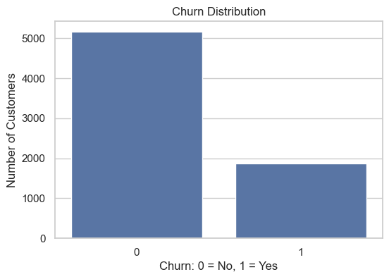

This chart shows the distribution of customers who churned and customers who stayed.
Insight:
The dataset is imbalanced, with more customers staying than leaving. However, the churn rate of 26.58% is still significant from a business perspective.

Figure 2: Churn Rate by Contract Type
Customers with month-to-month contracts had the highest churn rate.
Result:
- Month-to-month contract churn rate: 42.71%
Insight:
Customers with month-to-month contracts are much more likely to leave because they are not strongly committed to the company. Long-term contracts appear to reduce churn risk.

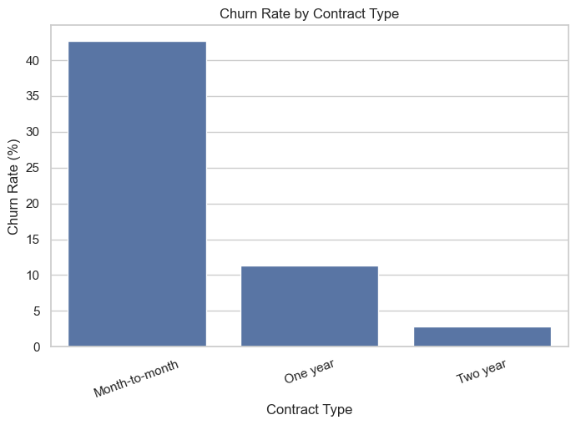

Figure 3: Churn Rate by Tenure Group
Customers in the 0–1 Year tenure group had the highest churn rate.
Result:
- 0–1 Year tenure group churn rate: 47.68%
Insight:
New customers are at the highest risk of churn. This suggests that the onboarding experience and early customer support are very important.
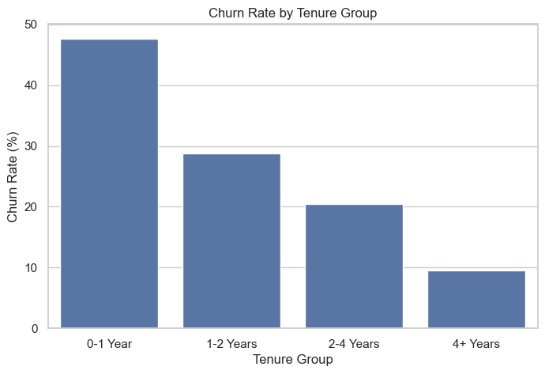

Figure 4: Churn Rate by Payment Method
Customers using electronic check had the highest churn rate.
Result:
- Electronic check churn rate: 45.29%
Insight:
Payment method is strongly related to churn behavior. Customers using electronic check may represent a less stable or less satisfied customer segment.

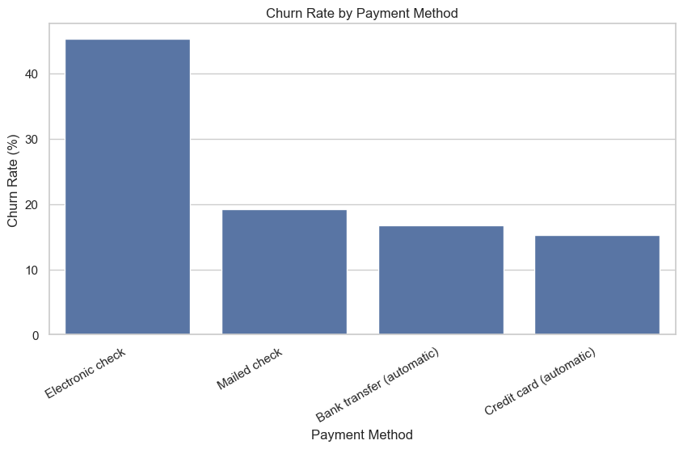

Figure 5: Monthly Charges by Churn Status
The analysis showed that customers with higher monthly charges appear more likely to churn.
Insight:
Customers may leave if they feel that the service cost is too high compared to the value they receive. Pricing and perceived value are important factors in customer retention.

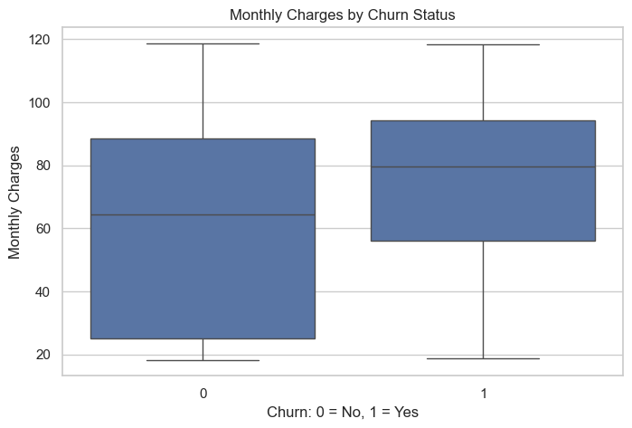

9. Key Business Insights
The main insights from the analysis are:
- The overall churn rate is 26.58%.
- Month-to-month contract customers have the highest churn rate at 42.71%.
- Customers in their first year have the highest churn rate at 47.68%.
- Customers using electronic check have the highest churn rate at 45.29%.
- Higher monthly charges appear to be associated with higher churn risk.
- Customer tenure is one of the strongest indicators of churn behavior.
- Contract type and payment method are important business factors that can be targeted through retention strategies.

10. Machine Learning Modeling
Two classification models were trained to predict customer churn:
- Logistic Regression
- Random Forest Classifier
The data was split into training and testing sets using an 80/20 split. Stratified sampling was used to preserve the churn distribution in both sets.
Categorical features were encoded using One-Hot Encoding, while numerical features were scaled using StandardScaler.

11. Model Evaluation
The models were evaluated using the following metrics:
- Accuracy
- Precision
- Recall
- F1 Score
- ROC-AUC
- Confusion Matrix
In churn prediction, Recall is especially important because the company wants to identify as many potential churn customers as possible before they leave.

Model Performance Results
Model | Accuracy | Precision | Recall | F1 Score | ROC-AUC
Logistic Regression | 0.7214 | 0.4852 | 0.7914 | 0.6016 | 0.8343
Random Forest | 0.7683 | 0.5538 | 0.6604 | 0.6024 | 0.8147

12. Best Model Selection
Although Random Forest achieved higher accuracy, Logistic Regression achieved better Recall and ROC-AUC.
This is important because churn prediction is not only about predicting the largest number of correct cases. The main business goal is to detect customers who are likely to churn before they actually leave.
Logistic Regression achieved:
- Recall: 79.14%
- ROC-AUC: 83.43%
Therefore, Logistic Regression was selected as the best model for this project.

13. Model Interpretation
Feature importance analysis showed that the most influential churn-related features were:
- Tenure
- Internet Service - Fiber optic
- Internet Service - DSL
- Contract type - Two year
- Monthly Charges
- Month-to-Month Risk
- Tenure Group
- Total Charges
- Streaming TV service
These results indicate that churn is mainly influenced by:
- How long the customer has stayed with the company
- The type of internet service
- The customer’s contract type
- The monthly cost of the service
- The level of customer commitment
From a business perspective, this means that customer loyalty, pricing, service type, and contract structure are key factors in churn behavior.

14. Business Recommendations
Based on the analysis and model results, the company should consider the following actions:

14.1 Target Month-to-Month Customers
Customers with month-to-month contracts have the highest churn rate. The company should offer discounts, loyalty points, or special benefits to encourage these customers to switch to one-year or two-year contracts.

14.2 Improve New Customer Onboarding
Customers in the first year have the highest churn risk. The company should improve the onboarding process by providing welcome offers, follow-up communication, technical support, and satisfaction checks during the first months.

14.3 Monitor Electronic Check Customers
Customers using electronic check have a high churn rate. The company should investigate whether this payment method is connected to customer dissatisfaction, payment issues, or lower engagement.

14.4 Review Pricing for High Monthly Charge Customers
Customers with higher monthly charges may leave if they do not feel they are receiving enough value. The company should create personalized bundles, loyalty discounts, or value-added services for this group.

14.5 Use the Model as an Early Warning System
The selected Logistic Regression model can be used to identify high-risk customers. The company can then contact these customers before they churn and offer personalized retention actions.

15. Business Value
This project provides business value by helping the company:
- Identify customers at risk of leaving
- Understand the main churn drivers
- Prioritize retention campaigns
- Reduce customer loss
- Improve customer experience
- Support data-driven decision-making
Instead of reacting after customers leave, the company can use this system proactively to reduce churn and protect revenue.

16. Limitations
Although the project provides useful results, there are some limitations:
- The dataset is a sample dataset and may not fully represent real company behavior.
- The model was trained on historical customer data only.
- External factors such as competitor offers, customer complaints, and service quality were not included.
- Advanced model tuning was not performed in this version.
- The project does not yet include a deployed dashboard or real-time prediction system.

17. Future Improvements
Future improvements may include:
- Building a Streamlit dashboard
- Adding SHAP values for deeper model interpretation
- Performing hyperparameter tuning
- Testing additional models such as XGBoost
- Adding customer segmentation
- Creating a prediction form for new customers
- Deploying the model as a web application
- Connecting the system to real-time business data

18. Conclusion
This project successfully developed a complete Customer Churn Intelligence System using Python, exploratory data analysis, machine learning, and business interpretation.
The analysis showed that churn is strongly related to contract type, tenure, payment method, internet service type, and monthly charges. Customers with month-to-month contracts, short tenure, electronic check payment, and high monthly charges showed higher churn risk.
Logistic Regression was selected as the best model because it achieved the highest Recall, making it more suitable for identifying customers who are likely to churn.
Overall, the project demonstrates how data science can help businesses move from simple reporting to proactive customer retention and smarter decision-making.

